|  |  |  |
| --- | --- | --- |
|  | **Assignment No. 1 Semester: Spring 2025**  **CS201 – Introduction to Programming** | **Total Marks: 20**  **Due Date: 2nd May, 2025**  **Syllabus: Lectures 1 to 8** |

**Instructions**

Please read the following instructions carefully before submitting the assignment solution:

It should be clear that your assignment will not receive any credit/marks if:

* The assignment is submitted after the due date.
* The submitted assignments do not open or the file is corrupt.
* The assignment is copied (from the internet or other students).

**Recommended Tools**

* Dev C++

**Topics Covered**

* Variables (int, float, string)
* Arithmetic operators (+, *, %, /)
* if-else conditional logic
* switch statements
* Loops

For good marks use all topics given above for the solution of the assignment.

**Assignment Submission Instructions**

You must submit only the ".cpp" file of your code on the assignments interface from your LMS account.

*An assignment submitted in any other format will not be accepted and will receive* ***zero marks****. No excuses will be accepted for submitting a solution file in any other format.*

For any queries related to the assignment, please contact [cs201@vu.edu.pk](mailto:cs201@vu.edu.pk).

**Problem Statement:**

Write a C++ program that uses items price from a menu and your VU ID to calculate the total and net bills according to the requirements given below.

**Requirement Instructions:**

* You are required to Hard-Code **your own** name and VU ID (e.g., BS123456789) & display it afterwards.
* Now, you have to ask a user to enter the numeric part of VU ID.
* Extract and display 5 digits from the middle of the numeric part asked in the above step:
* Remove 2 digits from the left and 2 from the right of the 9-digit number.
* For example, from 123456789, you will extract 34567.
* 12 from the left and 89 from the right will be removed.
* Each digit of 5 digits extracted in the above step (e.g., 34567) will be used as the quantity for a specific menu item:
* The leftmost is the 1st digit and the rightmost is the 5th digit.
* Digit 1 should be used for the quantity of Burger.
* Digit 2 should be used for the quantity of Pizza.
* Digit 3 should be used for the quantity of Fries.
* Digit 4 should be used for the quantity of Sandwich.
* Digit 5 should be used for the quantity of Cold Drink.
* The price of each menu item should be the same as shown in the sample output screenshot below.
* Multiply each menu item price by its designated quantity to calculate the total bill.
* Display the full billing details for each item including:
* Item name
* Quantity (from digit)
* Unit price
* Subtotal (quantity × price)
* Sample is shown in screenshot
* After processing all 5 items, calculate the total bill.
* If the total bill is greater than or equal to Rs. 5000, apply a 10% discount.
* Display the following at the end:
* Total before discount
* Discount amount
* Final payable amount
* Sample is shown in screenshot

**Note**: Remember that if you have not used your name and student id in the program your marks will be deducted.

**Sample Output:**

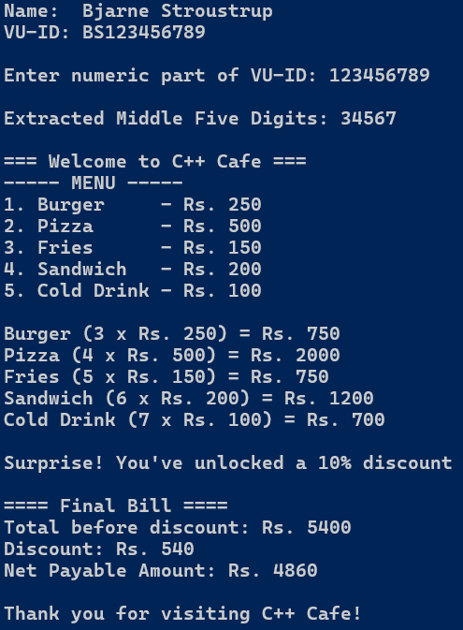

|  |  |
| --- | --- |
| **Lectures Covered:** | **Lecture # 1 – 8** |